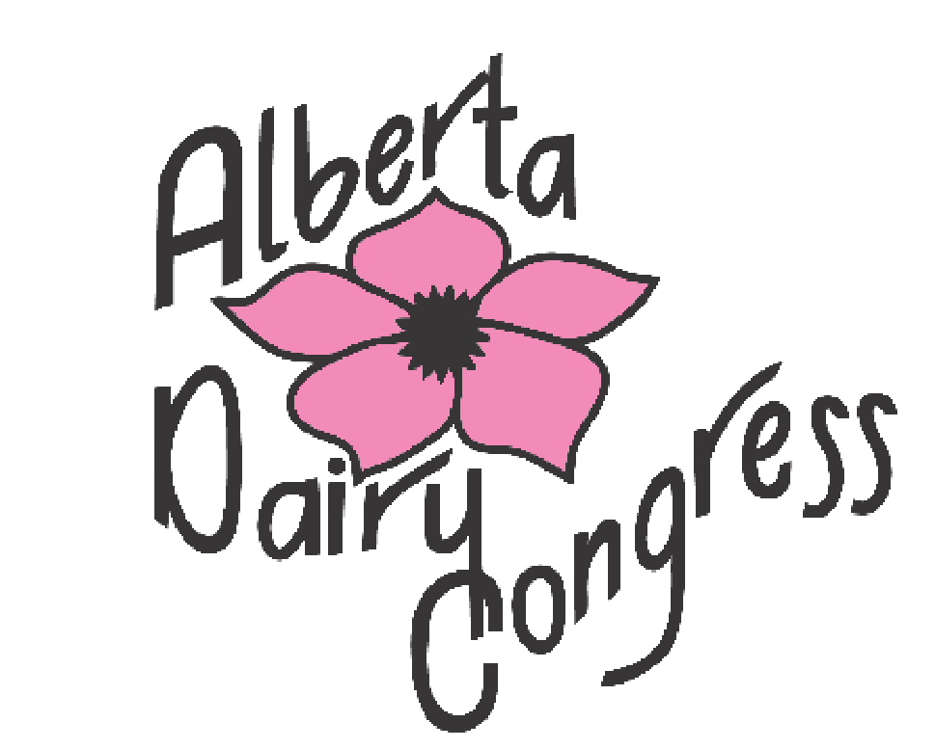

ALBERTA DAIRY
CONGRESS
2022
SHOW PROGRAM

June 1
-
2022
,
3

Co-operators Agrim Centre
Rimbey, Alberta

P O Box 20089

LEDUC, Alberta T9E 6R2
Phone: (587) 989-6766
www.albertadairycongress.c
a

ALBERTA DAIRY CONGRESS 2022

The Dairy Show Committee invites you to the 35th annual Alberta Dairy
Congress Holstein Show. We are also pleased to host the 15th annual RED & WHITE Holstein show, the only one in Western Canada and the 2nd annual Jersey show. The dairy shows at the congress allow exhibitors to showcase their animals to all dairy producers and dairy enthusiasts.

BACK AT: RIMBEY AGRIM CENTRE, RIMBEY ALBERTA for 2022 https://rimbeyagrimcentre.com/

STALL COMPETITION: starts June 1st, 2022 - ends June 3rd, 2022 4:00 pm

ALL ENTRIES will be accepted ONLINE ONLY at
www.assistexpo.ca/alberta-dairy-congress

Entries open MAY 1, 2022 ($40.00 per head) and close MAY 24, 2022 11:59PM
Questions: Call Corry @ (780) 499-7548 or cgross29@telus.net

All exhibitors are to wear SHOW HARNESSES this year.

PeeWee Show: June 1st, 2022 starting off the junior show

Banquet and Awards: June 3rd, 2022 @ 6:00 pm: Cost $25.00 per ticket Purchase tickets on the entry form online or with Corry Gross

We will be having live coverage of the Jersey Show June 2nd, 2022 and BW/RW Show June 3rd, 2022 https://www.cowsmo.com

The Dairy Congress Committee

Chairman: Orville Schmidt, Treasurer: John Mulcair, Directors:
Brenda Kozak, Dale Bienert, Sue Crest, Tom Hofstra, Corry Gross, Jason Rietveld, Katelyn Kozak, Chance Hofstra, Damien Rasmuson, Candice Prins, Lee Simanton, Maxime Ten-Have, Rebekah Mathers, Joanne vander Linde, Deanna Beck, Morgan Sangster

Show Times

JUNIOR SHOW & Wednesday, June 1st, 2022 Judge: Katelyn Kozak
PeeWee Show Start time: 5:00 pm New Sarepta, Alberta

JERSEY SHOW | Thursday, June 2nd , 2022 Judge: Mark Sweetnam
 | Start time: 5:00 pm Morden, Manitoba
HOLSTEIN SHOW | Friday, June 3rd, 2022 Judge: Mark Sweetnam
 | Start time: 9:00 am Morden, Manitoba

At the Holstein Show the Black & White Classes and the Red & White Classes will show alternately.

DAIRY SHOW GUIDELINES

Arrival Times: Animals may arrive on the grounds beginning at 12:00 pm on
Monday May 30th, 2022. All cattle must arrive by 4:00 pm on Tuesday May 31st, 2022. All livestock to be unloaded at the SOUTH SIDE OF THE AGRIM BUILDING (see map of grounds on the last page). We would prefer that all exhibitors would attend the awards and banquet and that no cattle be removed, prior to the completion of the show.

Rules & Guidelines: All animals must have plastic panel NLID tags to be allowed onto the grounds. Exhibitors will be expected to comply with the “Rules and Regulations for Showing Dairy Cattle” (listed on Holstein Canada web site). Due to space restrictions please store only 1 days’ worth of hay at your stall, leave the remainder in your trailer.

Bedding: Shavings and straw available on grounds, supply will be limited. Alberta Dairy Congress will be supplying big straw bales. If you would like to use small straw bales instead, exhibitors will have to supply them on their own.

General: Exhibitors must supply own milking equipment. A tank will be on site for milk collection. All exhibitors must put milk in the tank provided. Milk is not to be disposed of in the sewer system.

** Manure must be kept clean of garbage. Keep stall area clean and please put garbage in barrels provided throughout the barns. **

There will be a $250 charge to the exhibitor if garbage other than straw, shavings and manure is found in the stall after the show.

JUNIOR SHOW CLASSES
SHOWMANSHIP:
400P Pee Wee 8 years old and younger
400J Junior 9 - 11 years old (As of January 1, 2022)
400I Intermediate 12 - 14 years’ old
400S Senior 15 – 21 years’ old
Championship Showmanship Class
401 Spring Heifer Born March 1 2022
402 Winter Heifer Born Dec.1, 2021 - Feb. 28, 2022
403 Fall Heifer Born Sept. 1, 2021 – Nov. 30, 2021
404 Summer Yearling Born June 1, 2021 - Aug. 31, 2021
405 Spring Yearling Born March 1, 2021 - May 31, 2021
406 Winter Yearling Born Dec. 1, 2020 – Feb. 28, 2021
407 Fall Yearling Born Sept. 1, 2020 – Nov. 30, 2020

JUNIOR CHAMPION AND RESERVE JUNIOR CHAMPION (BANNER ONLY)

JERSEY SHOW HEIFER CLASSES

300 Junior Calf Born March 1 2022
301 Intermediate Calf Born Dec. 1, 2021 – Feb. 28, 2022
302 Senior Calf Born Sept. 1, 2021 – Nov. 30, 2021
303 Summer Yearling Born June 1, 2021 – Aug. 31, 2021
304 Junior Yearling Born March 1, 2021 – May 31, 2021
305 Intermediate Yearling Born Dec. 1, 2020 – Feb. 28, 2021
306 Senior Yearling Born Sept. 1, 2020 – Nov. 30, 2020

Junior Breeders Herd
Junior Champion
Junior Premier Breeder and Junior Premier Exhibitor

JERSEY SHOW COW CLASSES

307 Summer Junior 2 Year Old Born June 1, 2020 – Aug. 31, 2020
308 Junior 2 Year Old Born March 1, 2020 – May 31, 2020
309 Senior 2 Year Old Born Sept. 1, 2019 – Feb. 29, 2020
310 Junior 3 Year Old Born March 1, 2019 – Aug. 31, 2019
311 Senior 3 Year Old Born Sept. 1, 2018 – Feb. 28, 2019

Intermediate Champion
312 4 Year Old Born Sept. 1, 2017 – Aug. 31, 2018
313 5 Year Old Born Sept. 1, 2016 – Aug. 31, 2017
314 Mature Cow Born prior to Sept. 1, 2016
315 Lifetime Component Class official lifetime total solids of 4500kg
or more (combined Fat & Protein)

Senior Breeders Herd
Grand Champion

Premier Breeder and Premier Exhibitor

HOLSTEIN SHOW HEIFER CLASSES

100 B & W Summer Calf Born June 1, 2022 – Aug. 31, 2022
200 R & W Summer Calf Born June 1, 2022 – Aug. 31, 2022
101 B & W Spring Heifer Born March 1, 2022 – May 31, 2022
201 R & W Spring Heifer Born March 1, 2022 – May 31, 2022
102 B & W Winter Heifer Born Dec. 1, 2021 – Feb. 28, 2022
202 R & W Winter Heifer Born Dec. 1, 2021 – Feb 28, 2022
103 B & W Fall Heifer Born Sept. 1, 2021 – Nov. 30, 2021
203 R & W Fall Heifer Born Sept. 1, 2021 – Nov. 30, 2021
104 B & W Summer Yearling Born June 1, 2021 – Aug. 31, 2021
204 R & W Summer Yearling Born June 1, 2021 – Aug. 31, 2021
105 B & W Spring Yearling Born March 1, 2021 – May 31, 2021
205 R & W Spring Yearling Born March 1, 2021 – May 31, 2021
106 B & W Winter Yearling Born Dec. 1, 2020 – Feb. 28, 2021
206 R & W Winter Yearling Born Dec. 1, 2020 – Feb. 28, 2021
107 B & W Fall Yearling Born Sept. 1, 2020 – Nov. 30, 2020
207 R & W Fall Yearling Born Sept. 1, 2020 – Nov. 30, 2020

Junior Breeders Herd Black & White
Junior Champion Black & White
Junior Breeders Herd Red & White
Junior Champion Red & White
Junior Premier Breeder and Junior Premier Exhibitor

HOLSTEIN SHOW COW CLASSES

110 B & W Summer 2 Year Old Born June 1, 2020 – Aug. 31, 2020
210 R & W Summer 2 Year Old Born June 1, 2020 – Aug. 31, 2020
111 B & W Spring 2 Year Old Born March 1, 2020 – May 31, 2020
211 R & W Spring 2 Year Old Born March 1, 2020 – May 31, 2020
112 B & W Winter 2 Year Old Born Dec. 1, 2019 – Feb. 29, 2020
212 R & W Winter 2 Year Old Born Dec. 1, 2019 – Feb. 29, 2020
113 B & W Fall 2 Year Old Born Sept. 1, 2019 – Nov. 30, 2019
213 R & W Fall 2 Year Old Born Sept. 1, 2019 – Nov. 30, 2019
114 B & W Junior 3 Year Old Born March 1, 2019 – Aug. 31, 2019
214 R & W Junior 3 Year Old Born March 1, 2019 – Aug. 31, 2019
115 B & W Senior 3 Year Old Born Sept. 1, 2018 – Feb. 28, 2019
215 R & W Senior 3 Year Old Born Sept. 1, 2018 – Feb. 28, 2019

Intermediate Champion Black & White

Intermediate Champion Red & White
116 B & W 4 Year Old Born Sept. 1, 2017 – Aug. 31, 2018
216 R & W 4 Year Old Born Sept. 1, 2017 – Aug. 31, 2018 117 B & W 5 Year Old Born Sept. 1, 2016 – Aug. 31, 2017
217 R & W 5 Year Old Born Sept. 1, 2016 – Aug. 31, 2017 118 B & W Mature Cow Born Prior to Sept. 1, 2016
218 R & W Mature Cow Born Prior to Sept. 1, 2016
119 B & W Longtime Production 70,000 kg
219 R & W Longtime Producation 70,000 kg

Senior Breeder Herd Black & White
Best Bred and Owned Championship Black & White
Grand Champion Black & White
Senior Breeder Herd Red & White
Best Bred and Owned Championship Red & White
Grand Champion Red & White
Supreme Champion

Premier Breeder and Premier Exhibitor

Best Bred & Owned in the black & white milking classes will be presented by the Alberta Holstein Association with $100, and Red & White milking classes will be awarded $100.

ADDITIONAL ACTIVITIES

Alberta Holstein Judging Seminar
Judge: Garry Vanderpost Thursday June 2nd 9:00 AM

Taste of Crestomere Sale Thursday June 2nd 1:30 PM

Meals:
Taste of Crestomere Luncheon Thursday June 2nd 12:30 PM
Sponsored by
Gull Lake Veterinary
Leduc Farm Animal Hospital

Exhibitor Breakfast Friday June 3rd 7:00 AM
Sponsored by
More Than Just Feed

Banquet & Awards Friday June 3rd 6:00 PM
Cost: $25.00 per person

ACCOMODATIONS IN RIMBEY

Canalta Rimbey

Box 1790 Rimbey Canada
Phone: 403.843.3808
Email: canaltarimbey@canalta.com
Web: www.canaltahotels.com

A block of rooms has been reserved from May 30th, 2022 to June 4th, 2022 at a rate of $118.00 + taxes and fees.

Call the hotel and mention the Alberta Dairy Congress to reserve a room in this block. These rooms will be held until May 15th, after that there will be no guarantee of rooms, but the rate will be more.

Quality Inn & Suites®

Elaa Aki
General Manager
5501 50th Avenue Rimbey, AB
Phone: 403.843.2999
Cell: 778.846.7470
Fax: 403.843.2997

No blocked rooms offered. Availability is on first come, first serve basis.
Rate per night - $109.00 + taxes and fees
To book your room, call the hotel and mention the Agrim Rate

